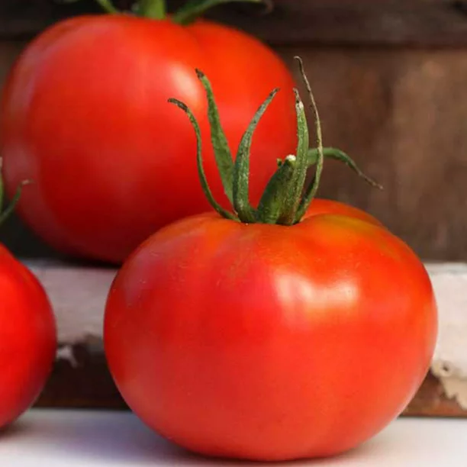
Marglobe VF (Marglobe Improved) Determinate
Marglobe has been in demand for several generations while many other varieties have come and gone. This strain has been selected for disease resistance. Red, medium-sized, 5-8 oz. fruits with firm walls and good flavor. Stocky, vigorous plants with excellent disease tolerance. Vines provide good protection from sunscald.
Culture: Moist, humusy [sic], deep, fertile loamy soil. Sensitive to cold, so protect plants with cover if temperatures are expected to dip below 50°F. Mulching helps to moderate soil temperature and to maintain soil moisture.

Spacing: Transplant seedlings 24 inches apart so that soil level is just below the lowest leaves. Indeterminate variety: Train to a vertical support and prune for best results.

Irrigation: Water in early morning, ideally. Always avoid splashing water on the tomato leaves. Tip: Mark your calendar 70 days from the day of transplant, reminding yourself to reduce watering (by half) to concentrate sugars.

Fertilization: Ensure abundant soil phosphorus for early high yields. Too much nitrogen causes rampant growth and soft fruits susceptible to rot. Abundant soil calcium prevents blossom end rot.

Disease Resistance to Alternaria Stem Canker, Cladosporium Leaf Mold, Fusarium Wilt Race 1, Nail Head Rust, Stemphylium Spot, Sun Scald, Verticillium Wilt.

Maturity/Harvest: 70 days from transplant

Seed source: https://www.southernexposure.com/products/marglobe-vf-marglobe-improved-tomato/

Tomatoes are compatible with basil, beans, chives, cucumbers, garlic, lettuce, marigolds, nasturtium, onion, parsley, and rosemary; all of which help control pests.
Tomatoes are incompatible with broccoli, cauliflower, corn, and dill. Carrots grown with tomatoes will have good flavor but stunted roots.

