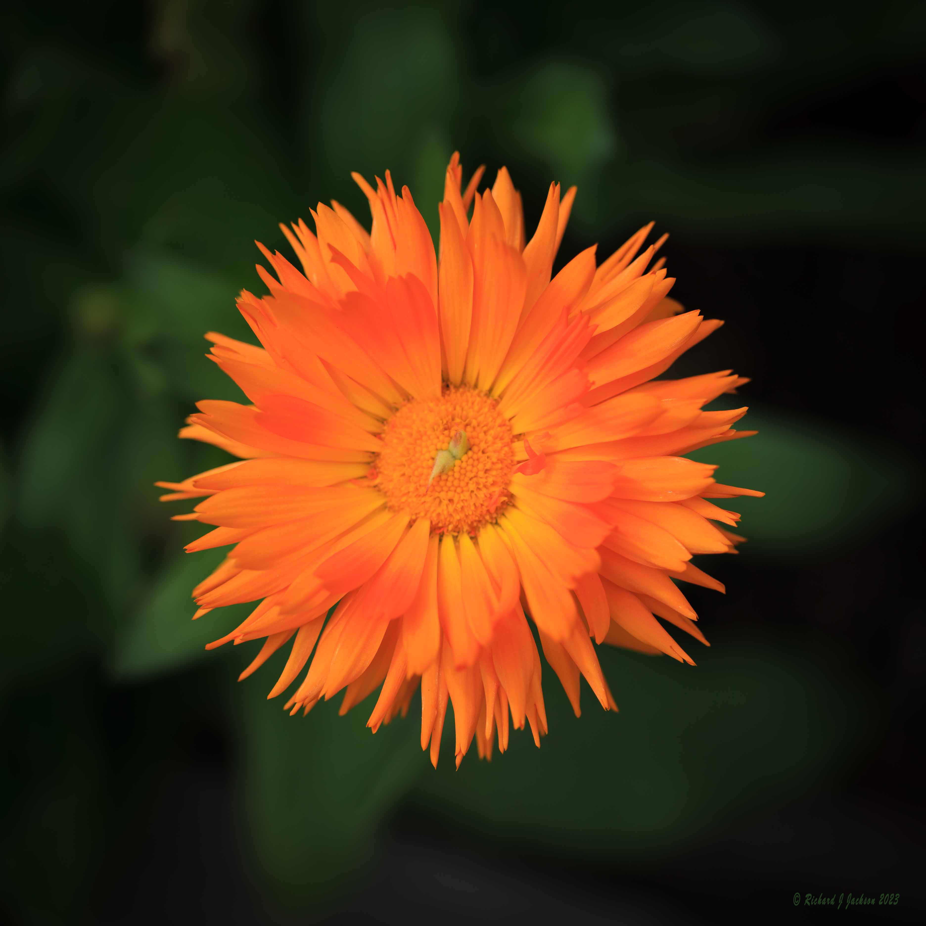 ©Photo by Rick Jackson
Radio Calendula, Calendula officinalis
Self-seeding, hardy annual, 18-24" tall, Radio was introduced to gardeners in the 1930s and is now quite hard to find. Beautiful orange flowers have quill-like edible petals. Well suited for pots.

Edible petals of the flowers can be used fresh or dried ("flower confetti") in soups, soufflés, rice dishes, baked goods, and to garnish desserts. Calendula is a popular choice for brightening up salad mix. Tangy slightly sweet flavor.
Note: Remove the petals from the flower base before consuming as the base can be quite bitter. Do not eat the calyx or flower centers.
Try making calendula oil or tea by picking the flowers at full bloom and letting the petals dry.
Calendula has been used medicinally for centuries. Ancient Romans grew them to treat scorpion stings! In the Middle Ages calendula was a common remedy for everything from smallpox to indigestion. Today’s herbalists use it to make a healing salve for sunburn, chapped lips, minor burns, cuts, and scrapes.

Culture:
Sun or part shade. Prefers cooler temperatures, so can benefit from filtered shade in hotter regions. Rich, well drained soil.

Planting:
Direct seed into average garden soil 1/4" deep. Germinates in 5-15 days at 70°F (21°C). Space plants 12-18" apart.

Caring:
For the best blooms, do not overwater. Regular deadheading helps prolong blooming.

Matures in 50-55 days.

Harvesting:
For cut flowers, cut stems long when bloom is 50% open and immediately place in water.
For culinary use, harvest flower heads when they fully opened, pull petals off before using in dishes. Do not eat the calyx or flower centers.
To dry, spread flowers out (away from direct sunlight) and turn occasionally. Note: When the flowers are crisp and dry store in an airtight container for up to a year. The petals can be used as a substitute for saffron, or as a garnish to add color and spice to meals.

Seed saving:
Developing seeds turn from green to pale tan and easily come loose from the head. Remove the seed head. Spread out to dry (away from direct sunlight) and thresh them to separate the seed from the husk. Store seeds in a cool, dry place.

https://www.seedsavers.org/radio-flower

https://www.almanac.com/growing-calendula-how-grow-pot-marigold

Calendula is a wonderful companion plant in the garden. Bees and native pollinators are drawn to these flowers, making them a useful addition to your vegetable garden. Plus, calendula repels many pests.

