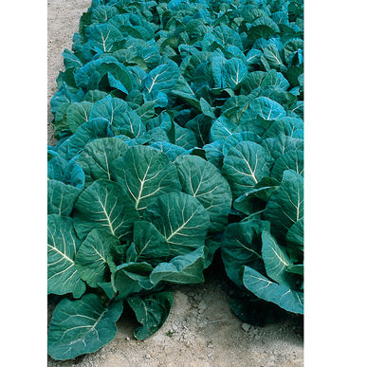
COLLARD, Flash FI, Hybrid
Very slow to bolt, Flash offers repeated harvests of dark green, smooth leaves and is very high yielding.
Culture: Collards prefer a fertile, well-drained soil high in organic matter with a pH range of 6.0–7.5. They thrive with cooler growing temperatures, between 55–75°F, optimum being 60–70°F, but will produce good crops under warmer conditions.
Spacing: Direct sow: For baby leaf production, sow 60 seeds per foot in a 2–4" wide band ¼–½" deep. If bunching, sow 3–4 seeds every 12–18", ½" deep, in rows 18–36" apart. Thin to 1 plant per group. When transplanting seedlings, set into ground every 18". They grow large!
Irrigation: Consistent moisture will produce the best quality leaves. Provide 1-1½ inches of water weekly.
Fertilization: Side-dress with slow-release fertilizer every four to six weeks to keep the plants growing, through repeated harvests.
Matures in 55 days. Can harvest when leaves are dark green and 10" long. Clip individual leaves. These are “cut and come again” greens.
https://www.johnnyseeds.com/vegetables/collards/flash-f1-collard-seed-2116.html
Collard greens are in the same plant family as cabbage, broccoli, kale, and cauliflower, so they should not be planted together. If planted in large quantities together, they will use the same nutrients in the soil, resulting in generally less nutrients that the plants need. Plant collard greens with hysop, thyme, and artemesia. These plants are also known as cabbage moth repellers. Dill is also a beneficial companion plant to collard greens, as it attracts wasps that prey on cabbage worms. Potatoes and onions are also good companion vegetables because they draw different types of nutrients in the soil than collard greens, which prevents the need for additional fertilizer for the collards. http://heritagegarden.uic.edu/collard-greens-brassica-oleracea

