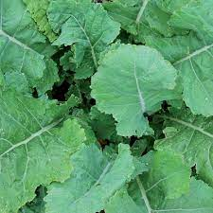
Collards, Georgia Southern
Non-heading plants grow 2-3 feet tall with large cabbage-like blue-green leaves that are tender, mild, and juicy. Historic collard first released around 1880. Slow to bolt and tolerant of heat and cold.
Culture: Collards prefer a fertile, well-drained soil high in organic matter with a pH range of 6.0–7.0. Consistent moisture will produce the best quality leaves. They thrive with cooler growing temperatures, optimum being 60–70°F, but will produce good crops under warmer conditions.
Spacing: 24-36 inches
Irrigation: Water regularly, applying 1 to 1.5 inches of water per week. If it does not rain, water enough to equal that amount.
Fertilization: When plants are 4" tall, apply a high nitrogen fertilizer and side dress with compost every 4-6 weeks.
Maturity: 60-80 days. Harvest about 2 months after planting by clipping individual leaves. Cut and come again!
https://www.seedsavers.org/georgia-southern-collards
Collards are compatible with dill, onions, potatoes, tomatoes. No known plant incompatibilities, although some discourage growing collards near cabbage, broccoli, kale, and cauliflower, so they do not compete for the same nutrients in the soil.

