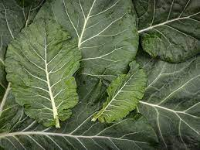
Collards, Morris Heading
HEIRLOOM. Also known as Carolina Cabbage collards, this 18-24" plant features smooth dark-green leaves with a loose head. Very slow-to-bolt.
Culture: Collards prefer a fertile, well-drained soil high in organic matter with a pH range of 6.0–7.0. Consistent moisture will produce the best quality leaves. Grow in temperatures 50–85°F.
Spacing: 12-24 inches
Irrigation: Water regularly, applying 1 to 1.5 inches of water per week. If it does not rain, water enough to equal that amount.
Fertilization: When plants are 4" tall, apply a high nitrogen fertilizer and side dress with compost every 4-6 weeks.
Maturity: 55-85 days. Harvest about 2 months after planting by clipping individual leaves. Cut and come again!
https://sowtrueseed.com/products/morris-heading
Collards are compatible with dill, onions, potatoes, tomatoes. No known plant incompatibilities, although some discourage growing collards near cabbage, broccoli, kale, and cauliflower, so they do not compete for the same nutrients in the soil.

