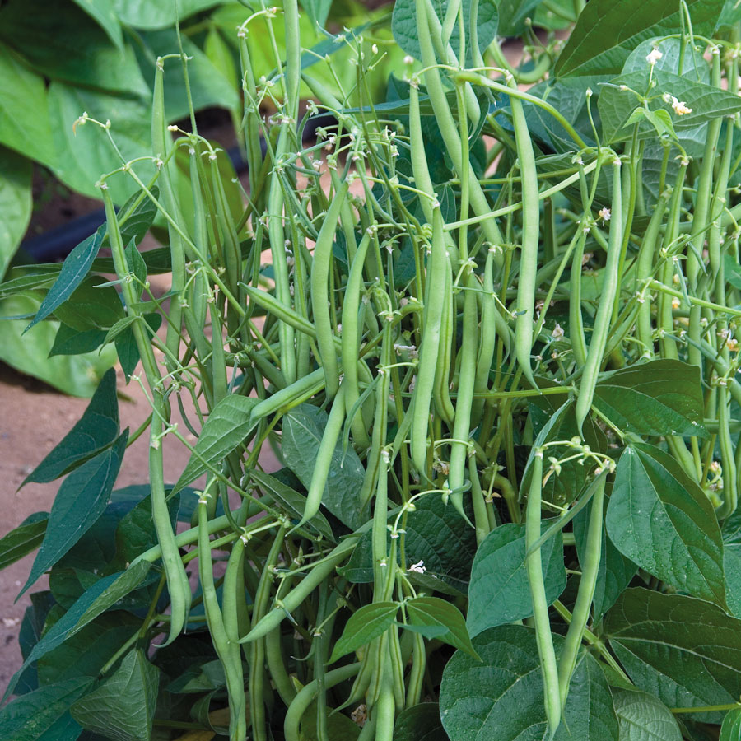
Mascotte French Filet Bush Beans
Bush-type haricot vert with dense but shallow roots and stringless beans that sit right on the top of the foliage, for easy picking. Generous crop of 5- to 6-inch pods, just ¼-inch in diameter but packed with rich, succulent flavor and crunchy texture. They're made to be julienned, but also taste delicious straight from the garden, pod and all. Mascotte reaches just 16 to 18 inches long and about 8 to 10 inches wide, so it's incredibly compact. Resistant to bean common mosaic virus, anthracnose, and halo blight, this dwarf bean is a treasure for any setting.

Soil Temperature: 70-90°F

Planting Depth: 1"
Seed Spacing: Sow seeds 2 to 3 inches apart in rows about a foot apart.

Beans are shallow rooted and can require up to 1/4 inch of water a day during hot weather

Maturity: Germinates in 5-10 days. Harvest in 55 days.

