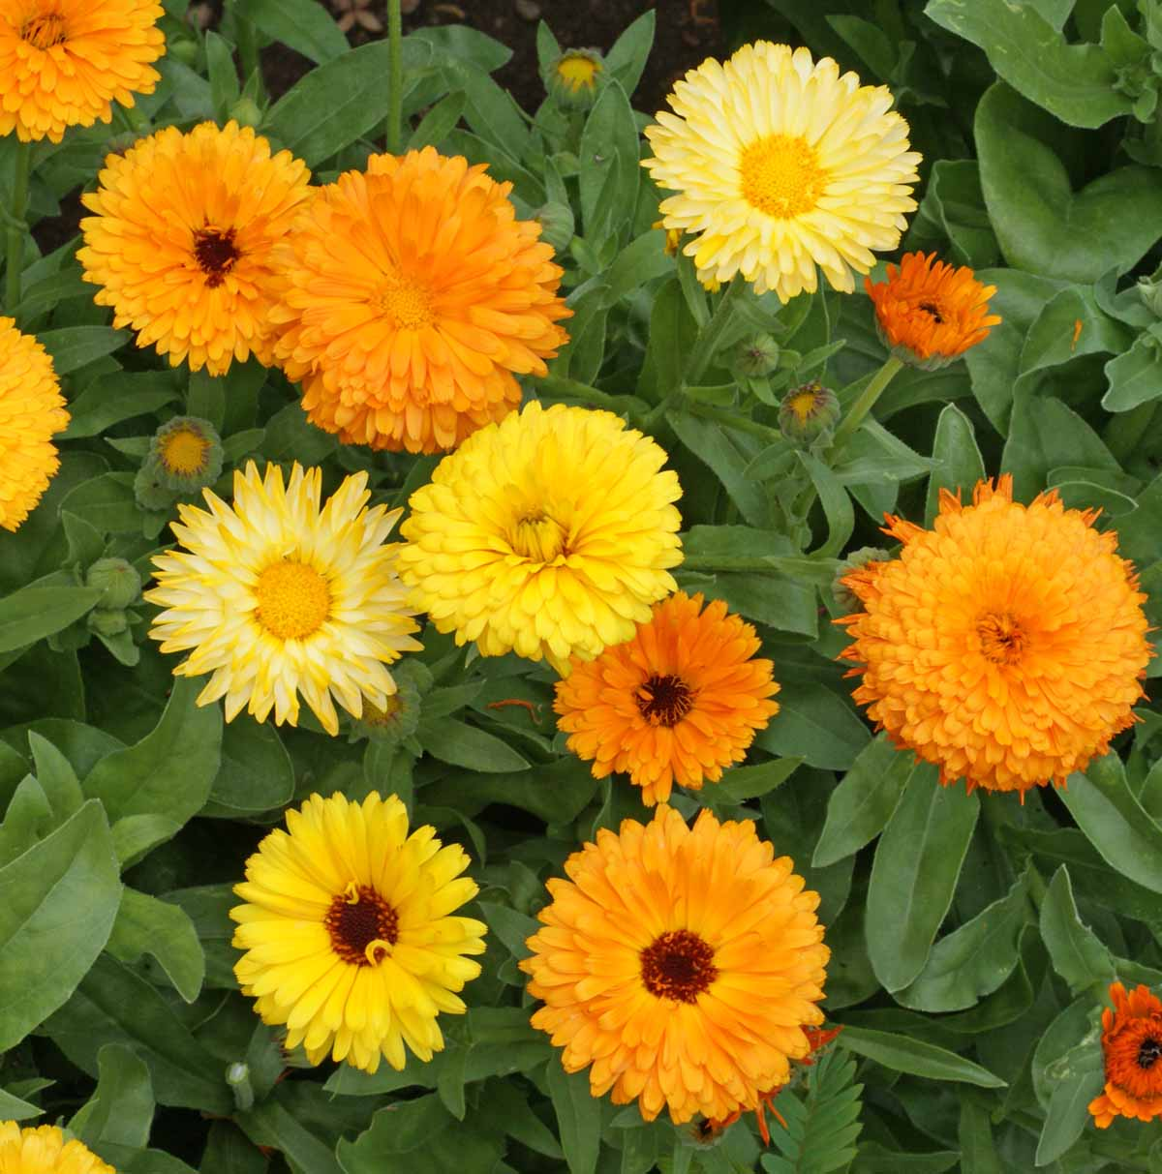

Fiesta Gitana Calendula

“This old-fashioned flower has a long history as both an ornamental garden plant and an herb. When dried the petals of calendula flowers provide a substitute for saffron; in times past they were used to give rich color to cheese or butter.” Used by some for medicinal purposes.

<https://www.everwilde.com/store/Calendula-Pacific-Beauty-Mix-Wildflower-Seeds.html>

* Plant adapts to any soil and can do well in average to poor soil, provided it is well drained. Grows well in containers.
* Since it prefers cooler temperatures, can benefit from filtered shade. In hotter regions may stop blooming in heat of summer and begin blooming again in fall.
* For the best blooms, do not overwater. To keep plant bushy and neat, occasionally pinch off developing stalks. Regular deadheading equals profuse blooming.
* For fresh flowers, cut stems long and immediately place in water.
* For culinary use, cut flower heads that have just opened and spread them out (away from direct sunlight) to dry completely, turning them occasionally. When the flowers are crisp and dry store in an airtight container for up to a year. The petals can be used as a substitute for saffron, or as a garnish to add color and spice to meals.
* When developing seed turns from green to pale tan and easily comes loose from the head, remove the seed head. Spread out to dry (away from direct sunlight) and thresh them to separate the seed from the husk. Store seeds in a cool, dry place.