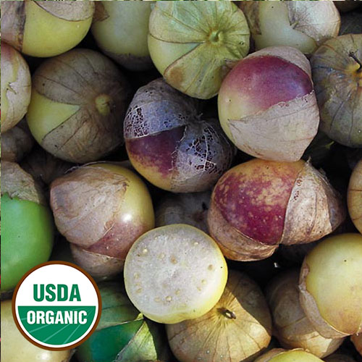
Dr. Wyche's Yellow Tomatillo

Given to SSE by Suzanne Ashworth, who obtained the seeds from the late Dr. John Wyche. Unique yellow tomatillo with contrasting purple blush (1½" diameter), delicious sweet flavor. Very prolific and easy to grow.

Culture is very similar to tomatoes.

Transplant outdoors when soil has warmed.

Space seedlings 24-36 inches apart.

Plants are self- supporting, but sprawl over a large area. Cage or trellis when space is limited.

Maturity/Harvest: 90-100 days

