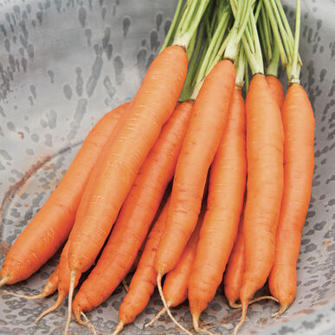
Romance
Pelleted (F1) Carrot Seed

High-yielding, blunt-tipped, deep orange roots average 6–7" long and have excellent uniformity. This full-season Nantes has a tapered root, rather than the true "cigar" shape of an early Nantes. Conventional seed with NOP-compliant* pelleting, making them easier to plant.

Culture: Carrots require well-drained soils, with a pH range of 6.0–6.8. Deep, loose, and fertile sandy loams and peat soils with good moisture-holding capacity grow the straightest and smoothest roots. Pelleted seed requires a little extra attention when it comes to watering, as it performs best with consistent, moderate soil moisture throughout the germination period. An initial watering will split or dissolve the pellet, but if the soil is allowed to dry out before the germination period is over, the seed may receive insufficient moisture for optimal germination.

Spacing: Sow seeds ¼-inch deep, barely covering with soil. They need light to germinate (typically 1-3 weeks). When carrot tops reach 2-inches in height, gently thin them to be 4-6 inches apart. Cut tops rather than pull, so that you do not disturb neighboring carrot roots. Sow seeds at 3 week intervals for a continuous supply of tender carrots at their prime.

Irrigation: Carrots like good drainage and regular watering, although the soil should be moist and not saturated. It is important not to allow soil to dry out.

Note: When the tops of the carrots begin to emerge from the soil, cover them with soil or organic mulch to keep them tender. Keep weeds under control to avoid carrots from becoming stunted.

Fertilization: When carrot tops are 3" high, apply fertilizer that is low in nitrogen and higher in potassium. Excessive nitrogen results in carrot roots cracking and splitting.

Maturity: 70 days. Carrots may be dug any time after they reach the desired size. Generally, the best harvest period lasts about 3 weeks (longer in cool, fall weather), after which time the roots may crack or the taste and appearance may decline.

*NOP-compliant means it has met all of the standards established by the USDA's National Organic Program.

https://www.johnnyseeds.com/vegetables/carrots/main-crop-carrots/romance-pelleted-f1-carrot-seed-3116JP.html

Carrots are compatible with beans, Brassicas, lettuce, onions, peas, peppers, pole beans, radish, and *tomatoes.

Avoid planting with dill, parsnips, and potatoes.

Generally speaking, it is a good idea to keep some space between root crops so they don’t compete for available phosphorus.

Planting carrots with aromatic herbs or onions may repel the carrot fly and its maggot. Chives also benefit carrots. Other compatible herbs include rosemary and sage.

*Carrots planted near tomatoes may have stunted roots, but will have exceptional flavor.

