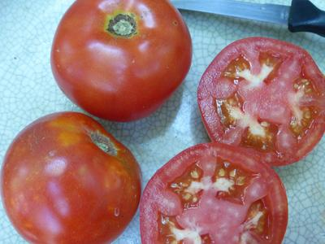
Tropic VFN
Developed by the University of Florida, this exceptionally disease-resistant variety produces sweet-flavored fruit averaging 8-9 oz that is thick-walled and tends to sit high on the vine under a protective cover of foliage. Recommended highly for hot, humid, disease-prone areas, especially where blight is a problem.

Climate: Average soil temperature should be 60-65 degrees F. when transplanting to garden.

Spacing: Staked plants should be spaced 24” apart. Caged plants should be spaced 36-48” apart in rows 60” apart. Transplant so that soil level is just below the lowest leaves. Train to vertical support or set cage into ground immediately after transplanting.

Irrigation: Require 1-2 inches of water each week, depending on weather conditions. Water early in the day and avoid getting water on stem and foliage to prevent disease. Keep soil evenly moist.

Fertilizer: High levels of phosphorus are necessary to produce good yields. Too much nitrogen after transplanting will delay flowering.
Matures 80 days after transplant.

https://www.southernexposure.com/products/tropic-vfn-tomato/

Tomatoes are incompatible with broccoli, cauliflower, corn, and dill. Carrots grown with tomatoes will have good flavor but stunted roots. Compatible with basil, beans, chives, cucumbers, garlic, lettuce, marigolds, nasturtium, onion, parsley, and rosemary; all of which help control pests.

