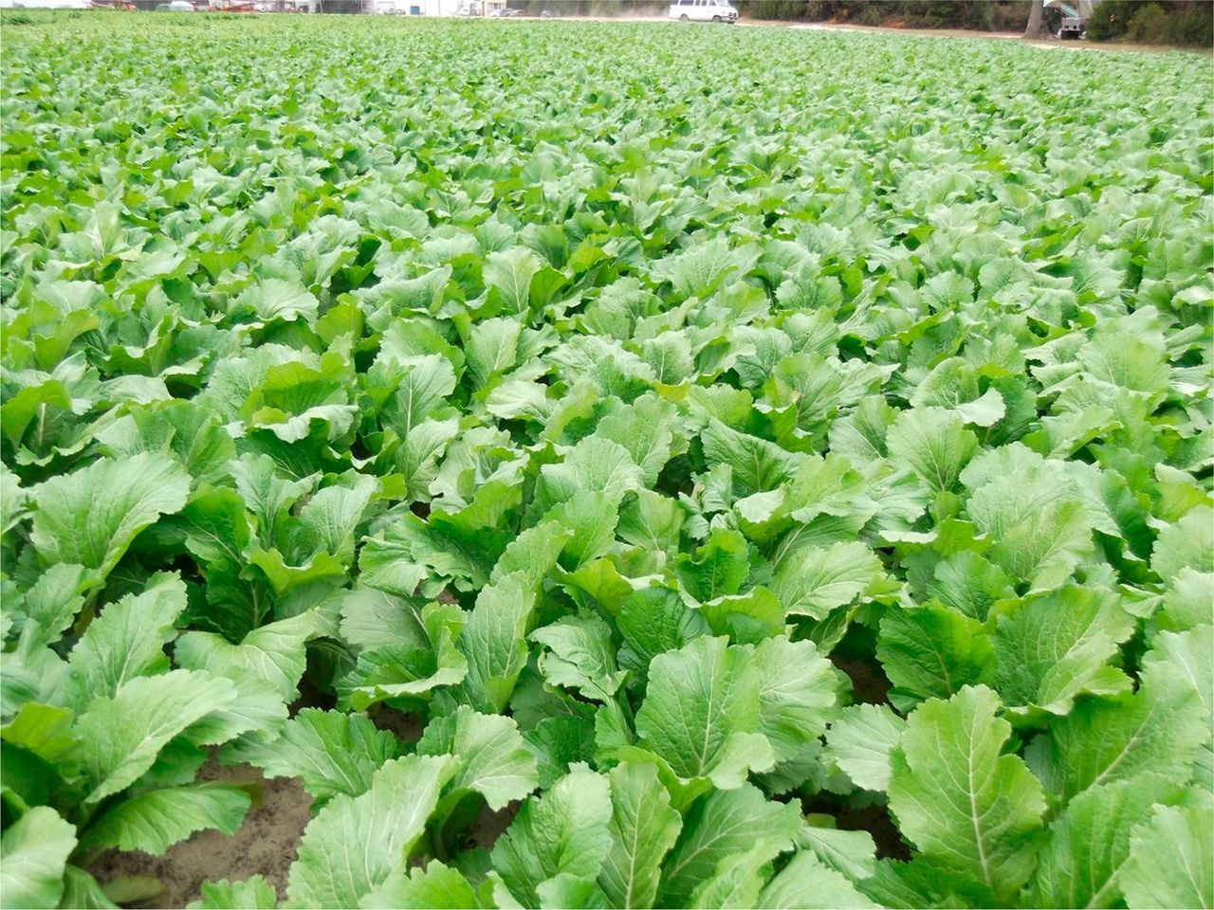
Carolina Broadleaf Mustard Greens
Old favorite “Florida Broadleaf” mustard is now having big problems with a new bacterial blight, so Carolina breeders have come to the rescue and added needed resistance! 16-24 in. tall plants, green leaves, pick them small for salads, or larger for cooking.

Culture: Ideal soil temperature 50-75°F. Loosen the soil with a rake to a depth of 12 to 15 inches, then mix in a 2-inch to 4-inch layer of compost.
Spacing: Direct sow 1/4 inch deep. Thin to 8-12 inches apart in rows 10-12 in. apart.
Irrigation: Greens need consistent water to produce delicious, tender leaves. Ideally, use a soaker hose or drip irrigation to provide even, regular moisture.
Fertilization: Apply a nitrogen-rich fertilizer every 1-2 times during the growing period.
Maturity: 42 days.
https://www.southernexposure.com/products/carolina-broadleaf-mustard/

Compatible with peas and cabbage. Can also grow with beans, broccoli, Brussels sprouts, cauliflower, celery, lettuce, onions, squash, spinach, Swiss chard and tomatoes.
Do not plant potatoes or other root vegetables, as they can compete for nutrients and reduce crop size and yield. Other plants that do not do well with turnips are radishes and mustard.

