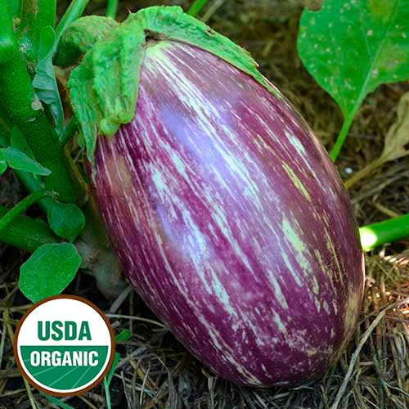
Lastida De Gandia Eggplant
Listada de Gandia is a treasure. This prized variety bears sweet, tender, thin-skinned, stunning eggplant. It likely originated in Spain (its name translates as “Grown in Spain”), where it is still revered today. The small 14" plants produce heavy yields of high-quality, 8" oval white fruits with purple stripes and mild white flesh. The variety thrives in very hot weather.

Culture: Eggplant is very tender perennial, most often grown as an annual, requiring 100 to 140 warm days with temperatures consistently between 70° and 90°F to reach harvest. Grow in fertile (amended with aged compost or other rich organic matter) well-drained soil.

Spacing: Space seedlings 18-24 inches apart.

Irrigation: Provide evenly moist but not soggy soil. Try not to allow the soil to dry out.

Fertilization: Eggplant requires moderate amounts of fertilizer. Mix a vegetable fertilizer (ideally 1-part nitrogen to 2-parts phosphorus and potassium) into the soil about a week before planting and then apply a balanced fertilizer (that includes calcium) twice during the growing season.

Maturity/Harvest: 80-90 days from transplant. A grower’s review: “These are best at 6-8 inches, when they are tender and not bitter. Much bigger than that and they get a bit too seedy, and they can get quite big! We roasted them, made dip, and pickled Italian style.”

https://www.seedsavers.org/listada-de-gandia-organic-eggplant

Eggplant is a compatible neighbor with and benefits from growing alongside many plants. It has no incompatibility issues! Read more about this in the following blog, that will surely provide inspiration for planning your garden.
https://insteading.com/blog/companion-planting-for-eggplant/

