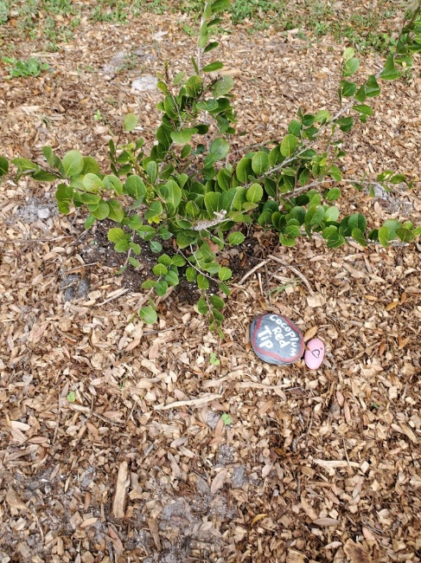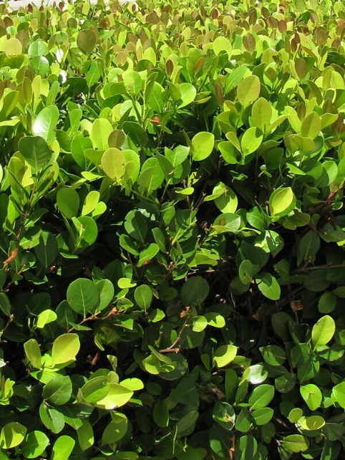
Red Tip Cocoplum
Chrysobalanus icaco

Can quickly grow into a large bush or small tree. Its foliage is nearly round, shiny, dark-green, leathery and very ornamental with the new growth tips displaying a bronze-red coloring. The fruit are edible, dark purple plum-like fruit. The flowers are a small and creme colored in spring and early summer with the fruit following shortly after in the summer. It is a plant utilized for honey production. Red-tip Cocoplum will grow in full sun to shade and it becomes very drought tolerant after establishment. Cocoplum can be very frost sensitive. They take pruning well and are easy to grow as a popular and widely used native ornamental.
https://www.wilcoxnursery.com/store/Red-Tip-Cocoplum-p190447451
‘Red Tip’ is a cultivar of the inland form of cocoplum that has become the dominant cocoplum hedge of south Florida capable of growing up to 25 feet or more in height.
https://edis.ifas.ufl.edu/ep553

