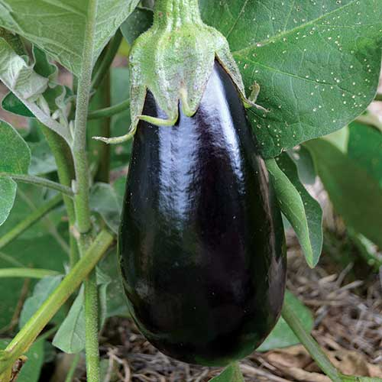
Florida High Bush Eggplant
This prolific eggplant was a standard market variety bred in Florida in the early 1900s for the commercial trade. Vigorous, upright, well-branched plants bear high-quality fruits continuously throughout the season, and its large purple-black pear-shaped eggplants are held high off the ground. Disease- and drought-resistant.

Space seedlings 18-24 inches apart.

Transplant outdoors once danger of frost has passed and soil is warm.

Maturity/Harvest: 75-85 days

