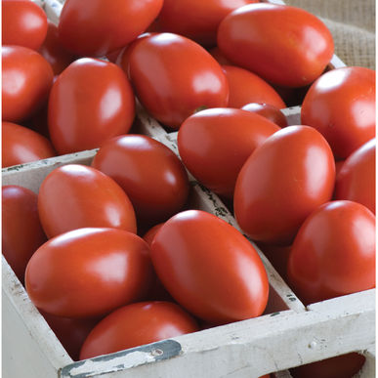
Granadero F1 Hybrid Plum - Organic
Granadero produces very high yields of uniform, attractive, bright red, 4-5 oz. tomatoes with very good flavor. Thick-walled fruit; ideal for fresh tomato sauces, salsas, and salads. Broad disease resistance package keeps Granadero healthy even under heavy disease pressure.

Space seedlings 24-36 inches apart. Transplant so that soil level is just below the lowest leaves.

Indeterminate: Train to a vertical support

Abundant soil phosphorus is important for early high yields. Too much nitrogen causes rampant growth and soft fruits susceptible to rot.

Maturity/Harvest: 75 days

Tomatoes are incompatible with broccoli, cauliflower, corn, and dill. Carrots grown with tomatoes will have good flavor but stunted roots. Compatible with basil, beans, chives, cucumbers, garlic, lettuce, marigolds, nasturtium, onion, parsley, and rosemary; all of which help control pests.

