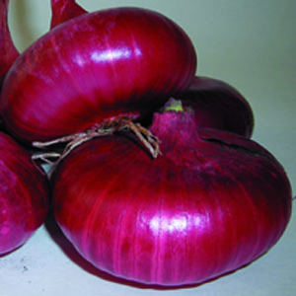
Red Marble Onion, Organic
Beautiful red cipollini that, compared to other 'Red Marble' strains, is more uniform with stronger thrips resistance, cleaner skins, and longer storage. Luxuriant, rich red color travels deep into the rings. A good hard-storage variety with thin necks.

Culture: Full sun and a fertile soil with a pH of 6.2-6.8 are preferable. Keep free of weeds.

Space: Sow in early spring in 2-4" wide bands or single rows 4" apart, about 1/2" between seeds. Cover 1/4- 1/2". Thinning is not necessary.

Irrigation: Consistent soil moisture

Fertilize: Apply first application (high nitrogen, such as blood meal) three weeks after planting and every 2 to 3 weeks thereafter.

Mature: 75 days. Pull by the bunch whenever needed. No skin forms until 2-3 months into the season, making mini onions easy to wash and prepare.

https://www.johnnyseeds.com/vegetables/onions/cipollini-onions/red-marble-organic-onion-seed-2717G.html
Onions are compatible with tomatoes, sweet peppers, spinach, lettuce beets, parsnips. Onions also repel insect pests of strawberries.

Incompatible with peas and beans.

