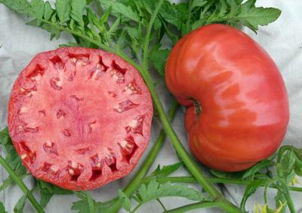
Mortgage Lifter* VFN
An improved version of Mortgage Lifter* with increased disease-resistance and more uniform fruit, ripening to red rather than pink-red. Large, 10-14 oz. fruits that are not as large as the original Mortgage Lifter, but the plants are much more productive. Note: Grows 6-7 ft. tall!

Climate: Average soil temperature should be 60-65 degrees F. when transplanting to garden.

Spacing: Staked plants should be spaced 24” apart. Transplant so that soil level is just below the lowest leaves. Train to high vertical support or set 6' cage into ground immediately after transplanting.

Irrigation: Require 1-2 inches of water each week, depending on weather conditions. Water early in the day and avoid getting water on stem and foliage to prevent disease. Keep soil evenly moist.

Fertilizer: High levels of phosphorus are necessary to produce good yields. Too much nitrogen after transplanting will delay flowering.
Matures 83 days after transplant.

https://www.southernexposure.com/products/mortgage-lifter-vfn-tomato/

Tomatoes are incompatible with broccoli, cauliflower, corn, and dill. Carrots grown with tomatoes will have good flavor but stunted roots. Compatible with basil, beans, chives, cucumbers, garlic, lettuce, marigolds, nasturtium, onion, parsley, and rosemary; all of which help control pests.
*The following history is based on portions of our 1985 taped interview with M.C. Byles who developed this tomato in the early 1930s while in Logan, WV. Mr. Byles is affectionately known as “Radiator Charlie.” He earned that nickname from the radiator-repair business he opened at the foot of a steep hill on which trucks would often overheat. Radiator Charlie had no formal education or plant-breeding experience, yet he created this legendary tomato by crossbreeding four of the largest-fruited tomatoes he could find: German Johnson, Beefsteak, an Italian variety, and an English variety. One of the four varieties was planted in the middle of a circle. Then, using a baby’s ear syringe, he cross-pollinated the center plant with pollen from the circle of tomatoes. Next year he selected the best seedlings: he planted the best seedling in the center and the rest in a circle around it. The pollination and selection process were repeated six more years until he had a stable variety. After Charlie developed and named this large, tasty tomato he sold plants for $1 each (in the 1940s) and paid off the $6000 mortgage on his house in 6 years. Each spring, gardeners drove as far as 200 miles to buy Charlie’s seedling tomatoes.

https://www.southernexposure.com/products/mortgage-lifter-radiator-charlie-s-tomato/

