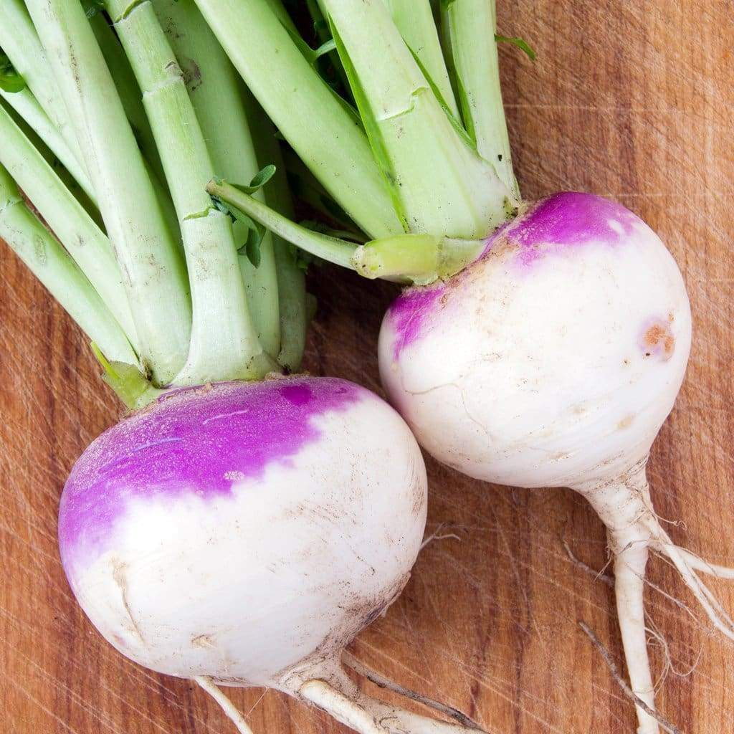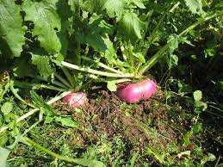
Turnips – Purple Top, White Globe

The classic name in American turnips, grown in the south for generations and beloved both for its smooth roots and for its flavorful, lobed, mid-green tops, which make excellent greens. Smooth, round roots are white below the soil line and bright purple above.

Nutritious young leaves are the classic southern greens perfect for soups, in vegetable gratin, or baked alongside other root vegetables. Harvest 2-3 leaves per root after they reach 4" in height. If you don’t harm the bulb, they will continue to grow.

Roots are best when harvested at 2–3 inches in diameter. They can also be harvested young (1-2 inches in diameter) for tender gourmet baby turnips. Turnip greens can be harvested any time after they reach four inches tall. If you don't harm the top of the bulb, the greens will continue to regrow.

Culture: A cool weather crop, plant after the hottest part of the summer.

Spacing: Direct sow 1/2" deep, 4-6" apart. For a prolonged harvest, succession plant every 10–14 days

Irrigation: At least 1 inch of water per week is vital for good root development.

Fertilizer: Fertilize turnips at planting and, only if necessary, six weeks after emergence with a low nitrogen fertilizer.

Mature in 55 days.

https://www.everwilde.com/search.html?q=purple%20top%20turnips&sortby=name&sorting=asc

Turnips are natural aphid repellents, protecting a wide variety of garden crops that are vulnerable to aphid invasion. Squash, tomatoes, celery, cabbage, broccoli, Brussels sprouts, beans, onions, garlic, lettuce, Swiss chard, spinach, cauliflower, and radishes all flourish when planted interspersed with turnips. Gardeners plant turnips around the base of supports or trellises for sweet peas and pole beans. Incompatible with potatoes or other root vegetables that can compete for nutrients reduce crop size and yield. Other plants that do not do well with turnips are radishes and mustard.

