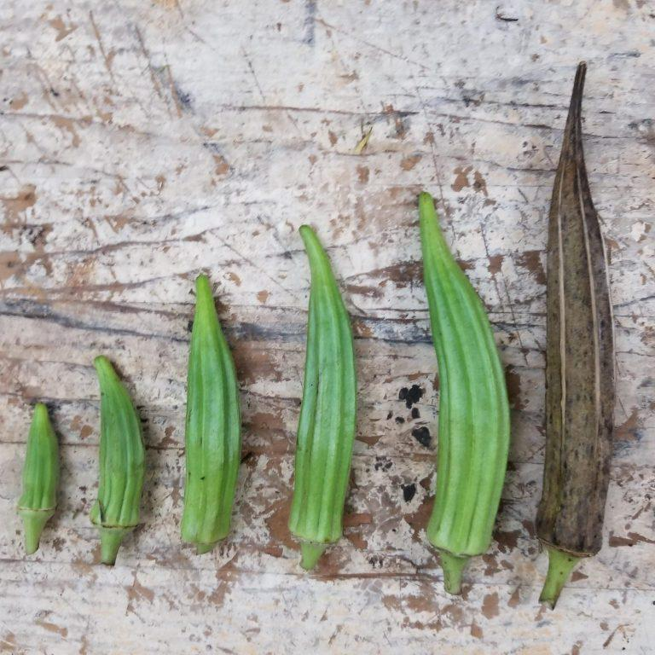
Okra – Kibler Family
Heirloom grown by the Kibler and Kinard families of Prosperity, SC for many generations. Jim Kibler says: "None of us ever grew any other okra because my father, grandmother, and aunt always considered it the best for a number of reasons. It germinated easily if soaked in water overnight and was not planted too early. It required no fertilizer and once established was not affected by drought. The pods were straight, neat, and stayed tender even when 8 or more inches long. They could be picked with little irritation to the skin. The flavor, to our taste, could not be equaled."
Culture: Direct sow in soil with temperatures between 70-90°F. Requires full sun and well-drained soil. It will tolerate a wide variety of soils and once established is heat and drought tolerant.
Sowing Seed: Direct sow seeds ½ inch deep, spaced 3-4 inches apart. Thin to mature spacing of 12 inches apart. Note: Okra has a thick seed coat and does not germinate easily. Soak seeds in water at room temperature overnight and/or nick hard seed coat prior to planting for improved germination.
Irrigation: Okra will tolerate some drought conditions, but in hot weather, make sure it gets at least an inch of water per week. Water the base of the plants and slowly enough so as not to erode the soil away. Avoid watering the tops of the plants as wet foliage is a breeding ground for fungi. Ideally, water in the early morning hours, so that the day’s sunlight evaporates any excess water that was not absorbed into the soil.
Fertilizer: Amend garden soil with compost before planting. When seedlings are 6 inches tall, apply a well-balanced fertilizer and follow up with a water soluble fertilizer (e.g. fish or seaweed emulsion) every 4 weeks.
Matures in 60 days. To increase productivity of plants, harvest every two days to promote further pod production.
https://sowtrueseed.com/collections/heirloom-seeds/products/the-kibler-family-okra?_pos=1&_sid=81815553d&_ss=r
Some of okra's best garden companions are plants that, like okra, need plenty of water. This includes cucumbers, melons, eggplant, and sweet or hot peppers.
Okra is useful as a shade plant to extend the growing season for “interplanted” lettuce, peas, and radishes.
Planting okra near tomatoes, peppers, and beans can reduce pests. For example, peppers repel cabbage worms that feast on young okra foliage. Planting basil near okra is also beneficial, as the strong fragrance repels pests that like okra, including flea beetles, stinkbugs, spider mites, aphids and whiteflies. Okra's tall plants, which can grow up to six feet, can also provide shade for the basil.
Planting sunflowers near okra assists with pollination. Although okra does not have incompatible plants, it is often advised not to plant okra where squash and sweet potatoes have been grown, as they are known to attract non-beneficial nematodes.

