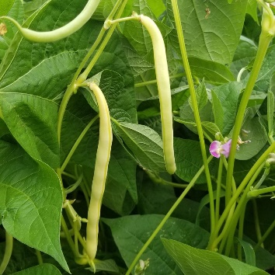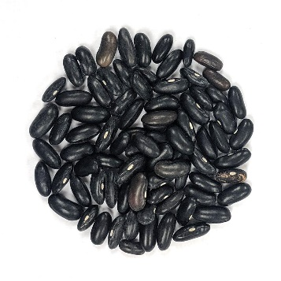
Bush Bean - Cherokee Wax

HEIRLOOM Bush-type plant produces excellent yields of 6" stringless yellow wax beans with black seeds. Excellent fresh, canned, or frozen.

Culture: Beans thrive in loamy soil. Amend sandy or clay soil with organic material before planting. Tip: Loamy soil is dark and crumbly. Test the soil by squeezing it in your hands. Clay soil stays in a ball and sandy soil falls apart completely. Loamy soil will hold its shape initially yet break apart when touched.

Spacing: Sow seeds 1–2 inches deep, 3–6 inches apart and cover lightly with loose soil. If planting multiple rows of beans, leave 1–2 feet of room between each row.

Irrigation: Beans have shallow roots and need regular watering if the weather is dry. Provide adequate, even moisture, especially at flowering time. Dry soil can result in low yields and fibrous pods.

Fertilizer: Beans do not require a vast amount of nutrients, but a light application of fertilizer can help your plants produce a better crop. Mix e fertilizer into the top 3–4 inches of soil. A fertilizer richer in phosphorus than in nitrogen or potassium is good for producing a strong crop yield. If you use a fertilizer high in nitrogen, your plant will grow a lot of leaves but few beans.

Mature in 58 days - You can continue sowing green bean seeds every 2 weeks for a continual harvest that lasts all season.

https://sowtrueseed.com/collections/beans/products/bush-bean-cherokee-wax?_pos=10&_sid=4bdd4466d&_ss=r

For companion planting benefits, grow beans near carrots, cucumbers, or corn; avoid planting them near onions.

