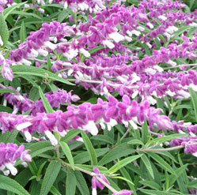
Mexican Sage
Salvia leucantha
Herbaceous perennial 4-5' high and wide. Grows in full sun, with rose-purple flowers that bloom throughout summer and fall on unique greenish-silver foliage. Effective as a border edging, mass planting, cascading down a wall, and for cut flowers.
Grow in full sun to light shade in average to rich, evenly moist, well-drained soil. Cold and drought tolerant, although does best with regular moisture. Once established, requires minimal care.
The Mexican bush sage is used solely for ornamental purposes, and it shouldn't be confused with the culinary sage herb.
Attracts butterflies and hummingbirds.
https://edis.ifas.ufl.edu/fp527

