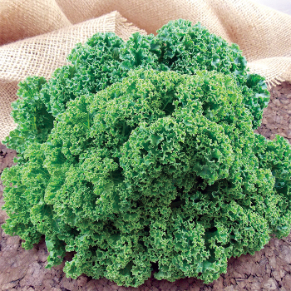
Prizm Hybrid Kale
2016 All-America Selections (AAS) National Winner. Tightly ruffled leaves on nearly stemless stalks, making the short, attractive plants ideal in gardens and containers alike. The excellent tasting, almost nutty-flavored leaves are tender enough to enjoy in fresh salads but also hold up well when cooked. Harvest early and often as plants are quick re-leaf.
Culture: Prefers cool temperatures. Mulch with food-grade straw to keep soil cool.
Spacing: Transplant each seedling 12-18" apart. Grows 10-24"high and 10-12" wide.
Irrigation: 1-1 ½ inches of water per week. Soil should be moist down to an inch into the soil.
Fertilization: Apply side dressing of compost and fertilize every two-four weeks to push the plants along in production and keep them healthy. Vermont Bean Company recommends NPK of 2-3-1.
Maturity: 55-60 days. Harvest early and often as plants are quick re-leaf.
https://www.vermontbean.com/category/s?keyword=Prizm+Hybrid+Kale
Kale is compatible with beets, celery, cucumbers, dill, lettuce, nasturtium, onions, spinach, Swiss chard, and many herbs (especially in the mint family). It is incompatible with tomatoes and strawberries.

