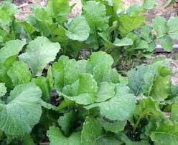
Seven Top (Southern Prize) Turnip Greens
Popular Southern variety often grown for winter green. Used for greens, not the roots, which are woody. Leaves grow 18-22 in. tall but should be harvested when young and tender. Pick them for raw eating and the Southern classic ‘Wilted Turnip Salad’ or grow them to full size for traditionally cooked greens.

Included in Slow Food USA’s Ark of Taste:
https://www.fondazioneslowfood.com/en/ark-of-taste-slow-food/seven-top-turnip/

Culture: Ideal soil temperature 50-75°F. Loosen the soil with a rake to a depth of 12 to 15 inches, then mix in a 2-inch to 4-inch layer of compost.
Spacing: Sow seeds 1/2" deep, 1-3" apart.
Irrigation: Greens need consistent water to produce delicious, tender leaves. Ideally, use a soaker hose or drip irrigation to provide even, regular moisture.
Fertilization: Apply a nitrogen-rich fertilizer every 1-2 times during the growing period.
Maturity: 45 days.
https://www.southernexposure.com/products/seven-top-southern-prize-turnip-greens/
Compatible with peas and cabbage. Can also grow with beans, broccoli, Brussels sprouts, cauliflower, celery, lettuce, onions, squash, spinach, Swiss chard and tomatoes.
Do not plant potatoes or other root vegetables, as they can compete for nutrients and reduce crop size and yield. Other plants that do not do well with turnips are radishes and mustard.

