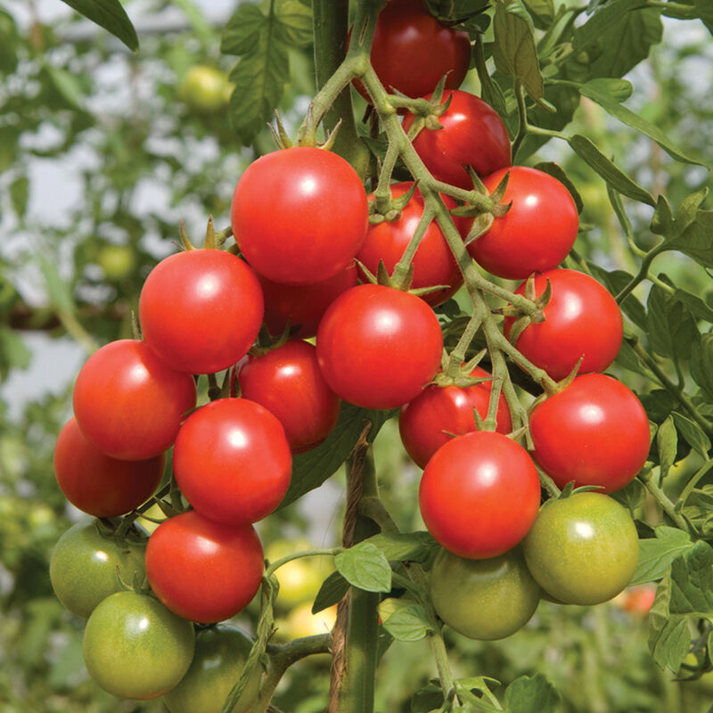
Sakura Organic (F1) Tomato
Early, delicious, attractive cherry tomatoes.

Real sweet tomato flavor and firmness without being hard. Among the first to ripen, Sakura keeps going all season long because of its disease resistance. Very tidy, compact plant fits well in tight spaces. Prolific yielder of bright red, shiny, medium-large cherry tomatoes that average 20–22 gm.

High resistance to Fusarium wilt, leaf mold, and tomato mosaic virus; and intermediate resistance to nematodes.

Climate: Transplant when soil temperature is at least 55-60°F. Vigorous plants start yielding early and bear right through the season.

Spacing: Indeterminate. Space seedlings 24 inches apart. Transplant so that soil level is just below the lowest leaves. Train to vertical support or set cage into ground immediately after transplanting.

Irrigation: Require 1-2 inches of water each week, depending on weather conditions. Water early in the day and avoid getting water on stem and foliage to prevent disease. Keep soil evenly moist.

Fertilizer: Apply tomato and vegetable fertilizer every 3-4 weeks once fruit forms. Caution: Too much nitrogen causes rampant growth and softer fruits.

Matures 55 days after transplant.

https://www.johnnyseeds.com/vegetables/tomatoes/cherry-tomatoes/sakura-organic-f1-tomato-seed-3853G.51.html

Tomatoes are incompatible with broccoli, cauliflower, corn, and dill. Carrots grown with tomatoes will have good flavor but stunted roots. Compatible with basil, beans, chives, cucumbers, garlic, lettuce, marigolds, nasturtium, onion, parsley, and rosemary; all of which help control pests.

