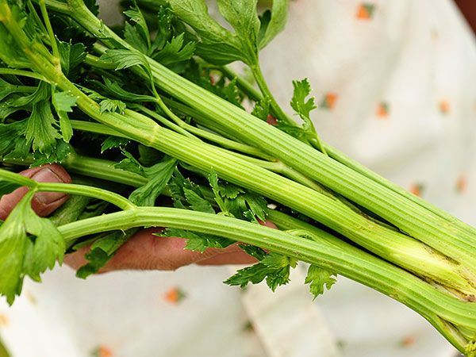
Celery, Tall Utah
30-inch medium-dark green plants, with 12-inch crisp, tender and tasty stalks.
Culture: Fertile soil with a pH range of 6.0–7.0. A generous amount of compost worked deeply into the soil before planting helps retain moisture and add nutrients.
Spacing: Sow seed no more than 1/8" deep. Space 8" apart in rows 2-1/2’ apart. Germination is slow, typically 14-21 days at 65-75 degrees F.
As the plants grow, soil can be mounded around the exposed root to keep it moist and cool.
Irrigation: Roots of celery rarely extend more than 8" in any direction and so must be kept well watered. Consider mulching with food-grade straw to conserve soil moisture.
Fertilization: Apply every 3-4 weeks with a high potassium fertilizer (4-4-8, for example).
Maturity: 110 days.
https://www.southernexposure.com/products/tall-utah-celery/
Compatible with bush beans, cabbage, cauliflower, onions, spinach, and tomatoes. Do not plant with carrots, parsley, parsnips, or turnips as they will compete for the same moisture and nutrients.

