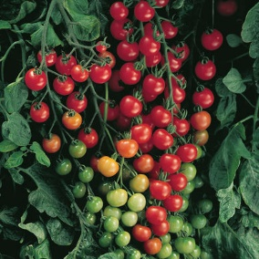
Supersweet 100
The classic sweet, red cherry tomato. Reliable with prolific yields of great tasting, 15-20 gm. fruits produced in large clusters. Widely adapted. High resistance to fusarium wilt and verticillium wilt.

Culture: Medium-rich soil with pH 6.0–6.8 preferred.

Spacing: Space seedlings 24 inches apart. Transplant so that soil level is just below the lowest leaves. Train to a vertical support and prune for best results.

Irrigation: Irrigate in early morning and avoid splashing water on the tomato leaves. Tip: Mark your calendar 55 days from the day of transplant, reminding yourself to reduce watering (by half) to concentrate sugars.

Fertilization: Fertilize to ensure abundant soil phosphorus for early high yields. Too much nitrogen causes rampant growth and soft fruits susceptible to rot. Abundant soil calcium and an even supply of soil moisture prevents blossom end rot.

Maturity/Harvest: 65 days from transplant

https://www.johnnyseeds.com/vegetables/tomatoes/cherry-tomatoes/supersweet-100-f1-tomato-seed-3981.html

Tomatoes are compatible with basil, beans, chives, cucumbers, garlic, lettuce, marigolds, nasturtium, onion, parsley, and rosemary; all of which help control pests. Tomatoes are incompatible with broccoli, cauliflower, corn, and dill. Carrots grown with tomatoes will have good flavor but stunted roots.

