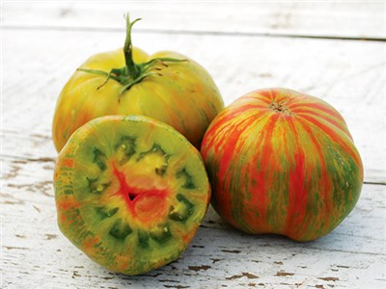
Berekley Tie-Dye Green Tomato
Incredibly colorful and delicious large-fruited slicing variety! Fruit runs 8 to 16 ounces. Exterior color is green with stripes in red and yellow. But the flesh is truly tri-color! Creamy green flesh infused with various shades of red and yellow. Each of these colors has a different flavor resulting in a spicy, sweet, tart tomato with good acid all in one fruit. Discovered in a planting of Beauty King. Fair to good production. A truly incredible new open-pollinated variety, and a new favorite of many chefs.

Indeterminate: Train to a vertical support

Space seedlings 24-36 inches apart. Transplant so that soil level is just below the lowest leaves.

Plant in fertile soil, amended with compost. Provide even moisture. Plant deeper than they were growing in the containers as it makes a stronger roots system. Apply a light compost tea every few weeks. Do not apply excessive nitrogen, which can promote excessive foliage and poor fruit set.

Maturity/Harvest: 75-80 days

Tomatoes are incompatible with broccoli, cauliflower, corn, and dill. Carrots grown with tomatoes will have good flavor but stunted roots. Compatible with basil, beans, chives, cucumbers, garlic, lettuce, marigolds, nasturtium, onion, parsley, and rosemary; all of which help control pests.

