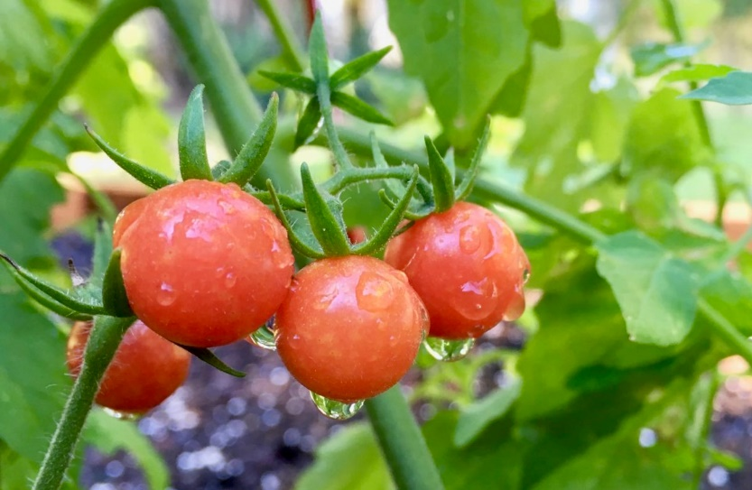

Everglade Tomato

Diminutive, about the size of a dime and usually smaller, with tremendous sweet taste. Great eaten right off the vine or in salads and as garnish. Often grown wild in non-trellised fashion (almost like a ground cover) with hundreds of fruit clusters on one plant! Will reseed year after year.

Indeterminate: Train to a vertical support

Space seedlings 24-36 inches apart. Transplant so that soil level is just below the lowest leaves.

Plant in fertile soil, amended with compost. Provide even moisture. Use good vegetable fertilizer (without excessive nitrogen, which can promote excessive foliage and poor fruit set.)

Maturity/Harvest: 50 days

Harvesting Tip: Instead of picking fruit by fruit, cut the entire cluster off the vine when all the fruit is most of the way ripe. Alternatively, break the fruit off the vine one by one with their little green hat on (the technical term is "peduncle") since the fruits skin tends to rip when its removed hastily.

Tomatoes are incompatible with broccoli, cauliflower, corn, and dill. Carrots grown with tomatoes will have good flavor but stunted roots. Compatible with basil, beans, chives, cucumbers, garlic, lettuce, marigolds, nasturtium, onion, parsley, and rosemary; all of which help control pests.

