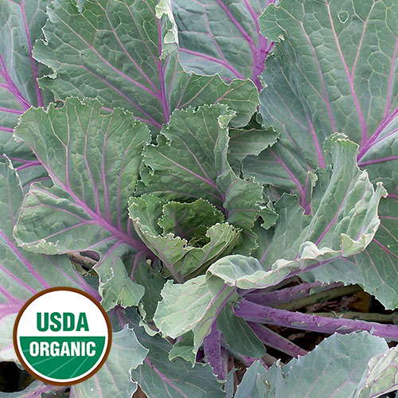

Collards, Old Timey Blue

Donated to Seed Savers Exchange in 1989 by Ralph Blackwell of Alabama. Ralph's family grew this variety for over a hundred years and his mother used it to make a dish similar to sauerkraut. Plants grow to 2' tall with blue-green leaves and purple stems/veins. Very good eating qualities.

Culture: Fertile soil is optimum.

Spacing: 24" apart, plants grow 2' tall (Collards are large, open plants. You can plant them more thickly and thin and eat young plants until you reach the desired spacing.)

Irrigation: 1.5 to 2 inches of water weekly

Fertilization: Work in compost 2 or 3 weeks before planting and side dress with compost or a slow-release fertilizer every four to six weeks to keep the plants growing, through repeated harvests.

Matures 60-80 days after transplant. Harvest leaves regularly to keep them sending out new leaves.

https://www.seedsavers.org/ole-timey-blue-organic-collard

https://edis.ifas.ufl.edu/mv053

